|  |  |
| --- | --- |
| **NAME :**  **PROJECT TITLE :**  **DEPARTMENT: COURSE DETAILS: COLLEGE:**  **TEAM ID:**  **NM ID : ZONE :** | **ARAVINDAVASAN. S**  **FACEBOOK ADS CAMPAIGN (METROBANNERS)**  **COMPUTER SCIENCE AND ENGINEERING**  **DIGITAL MARKETING**  **8151 – DHANALAKSHMI SRINIVASAN INSTITUTE OF – TECHNOLOGY**  **NM2023TMID03459**  **21B0D14D377F54F985749BD7A86F7BO8**  **12** |

MetroBanner

# Abstract:

MetroBanner is an innovative and pioneering force in the advertising industry. We are committed to revolutionizing the way brands connect with their audience, and we strongly believe that advertising should be accessible to everyone, memorable, and dynamic. To bring this vision to life, we have developed a groundbreaking approach that involves strategically placing steel banners in bustling urban environments.

MetroBanner is not just a service, it is a powerful tool that helps brands connect with their audiences in a unique way by turning public spaces into vibrant canvases of expression. We are committed to making advertising more accessible and inclusive so that everyone in the city can benefit from it. Our goal is to democratize advertising and ensure that it reaches every corner of the city.

Email:[hey.metrobanners@gmail.com](mailto:hey.metrobanners@gmail.com) Password: Vishva2003

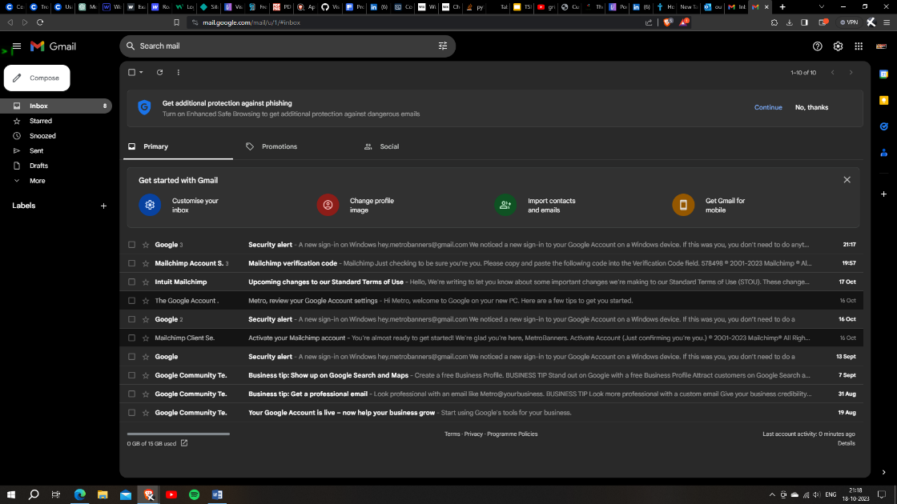

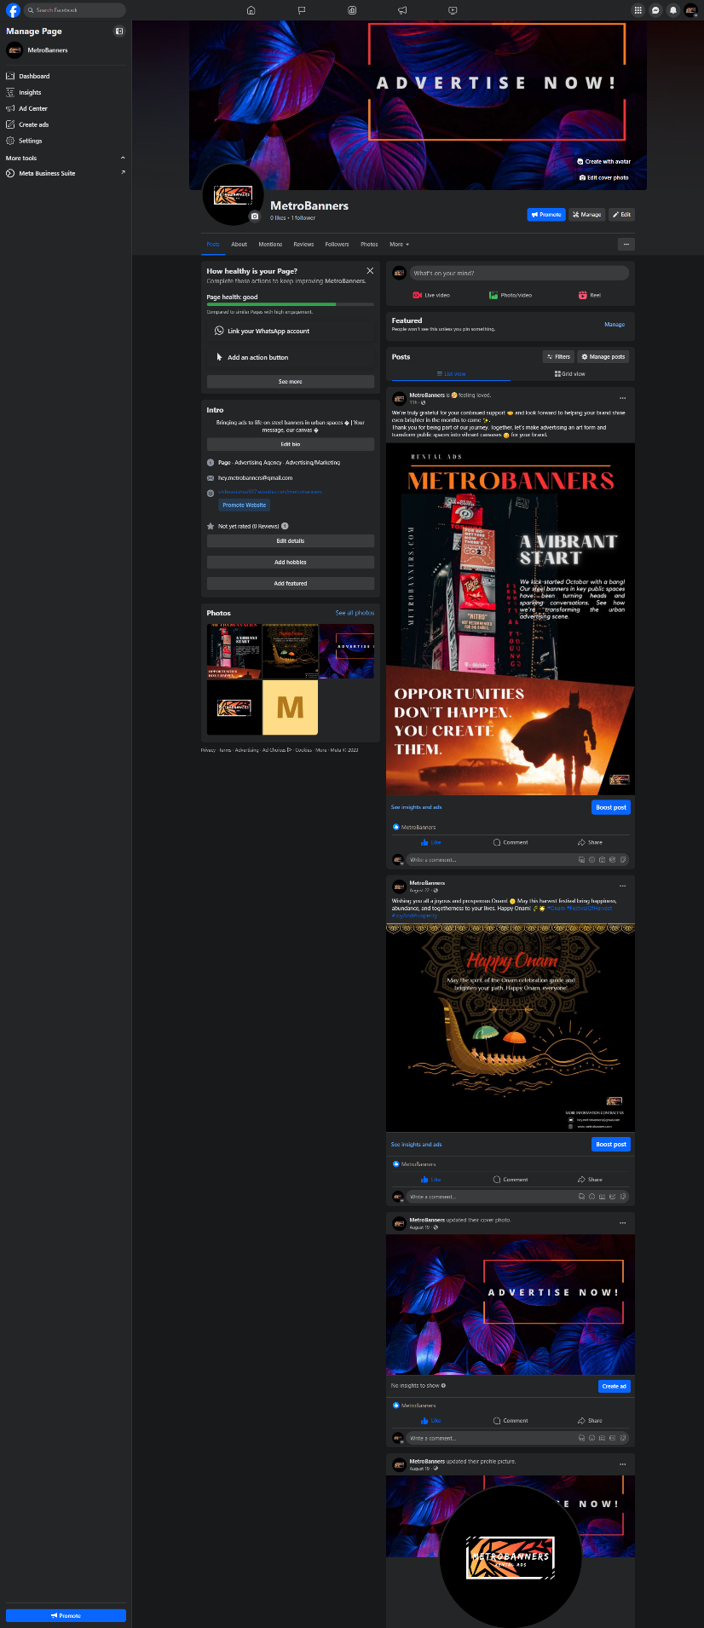

**Facebook:** <https://www.facebook.com/metrobanners23/>

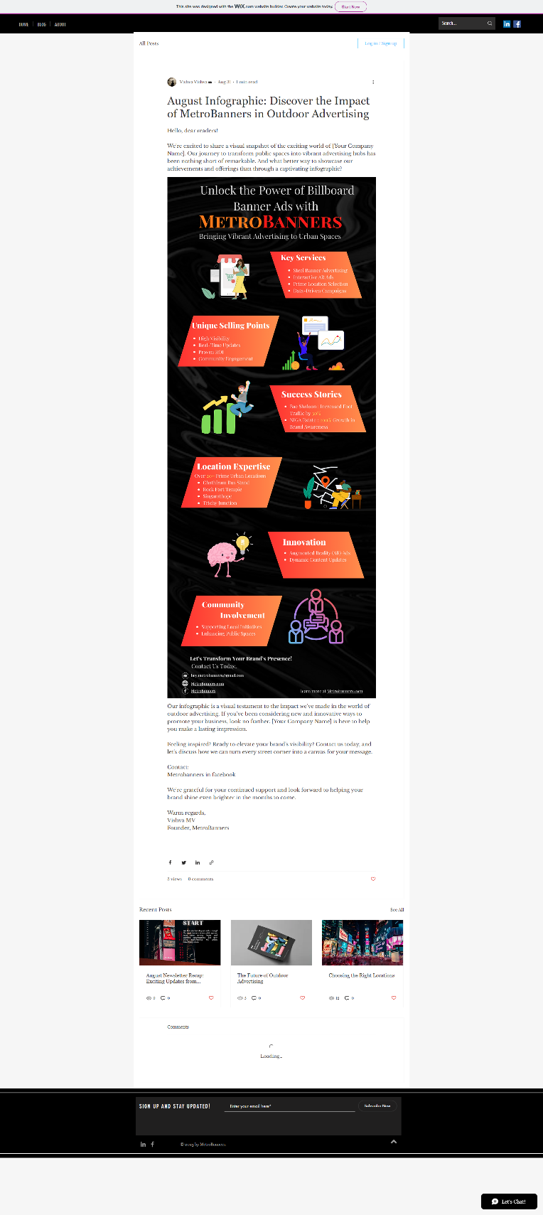

**Blog:** <https://vishvavishva587.wixsite.com/metrobanners/post/august-infographic-discover-the-impact-of-metrobanners-in-outdoor-advertising>

# FaceBook Ads Campaign

Step: 1 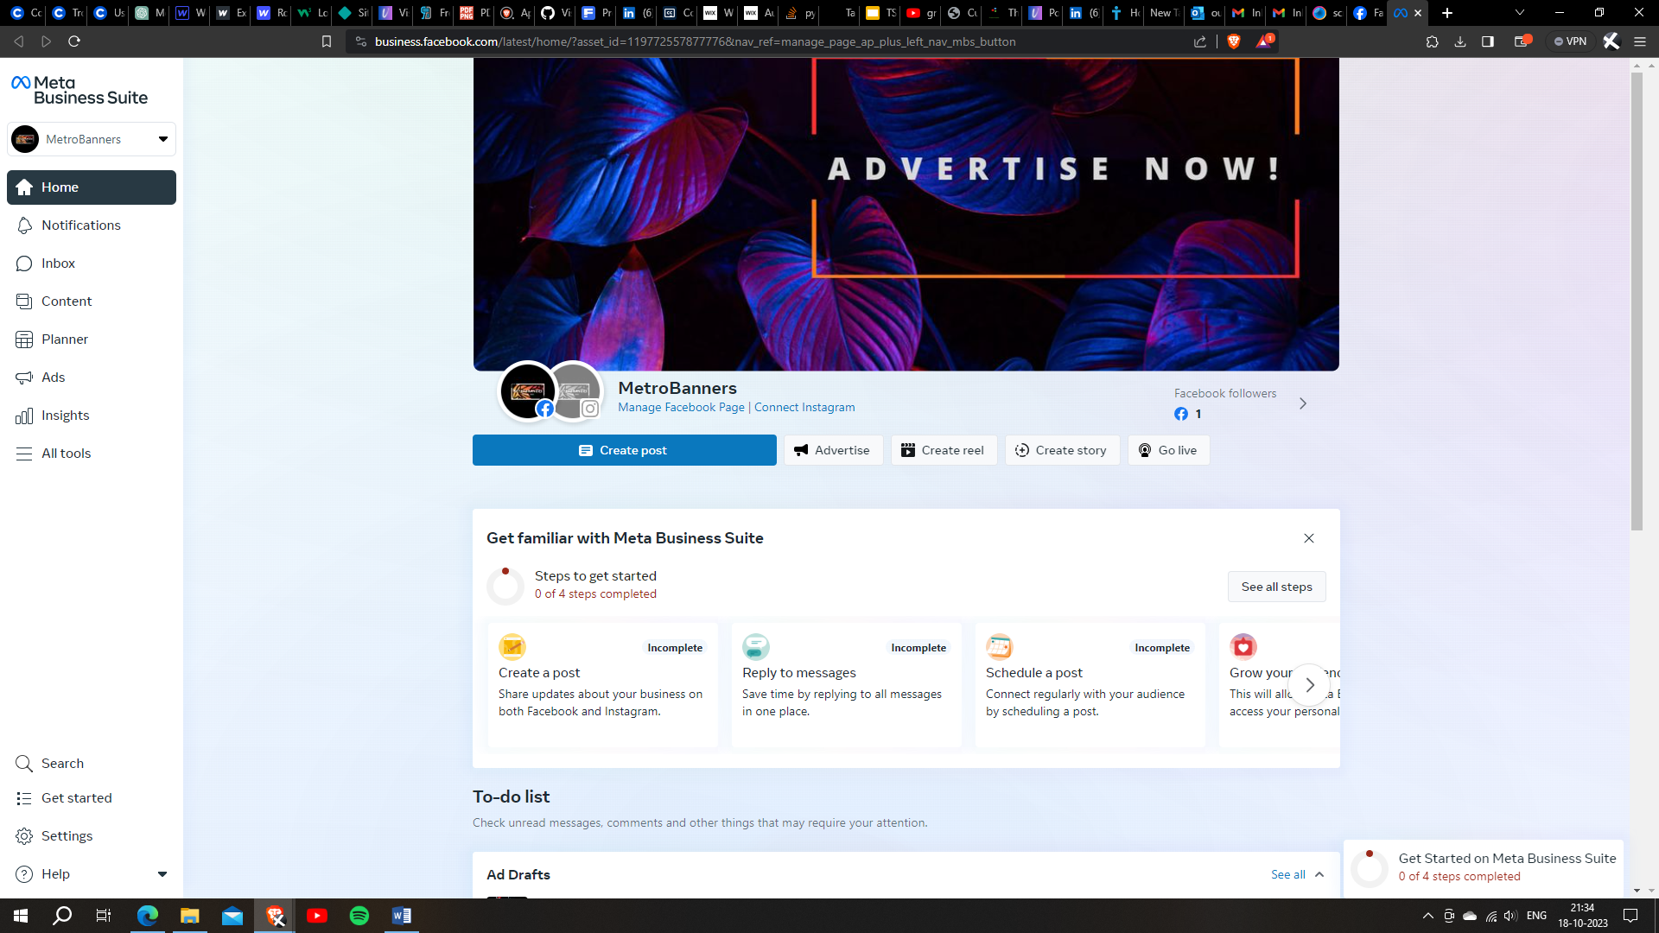

Step: 2

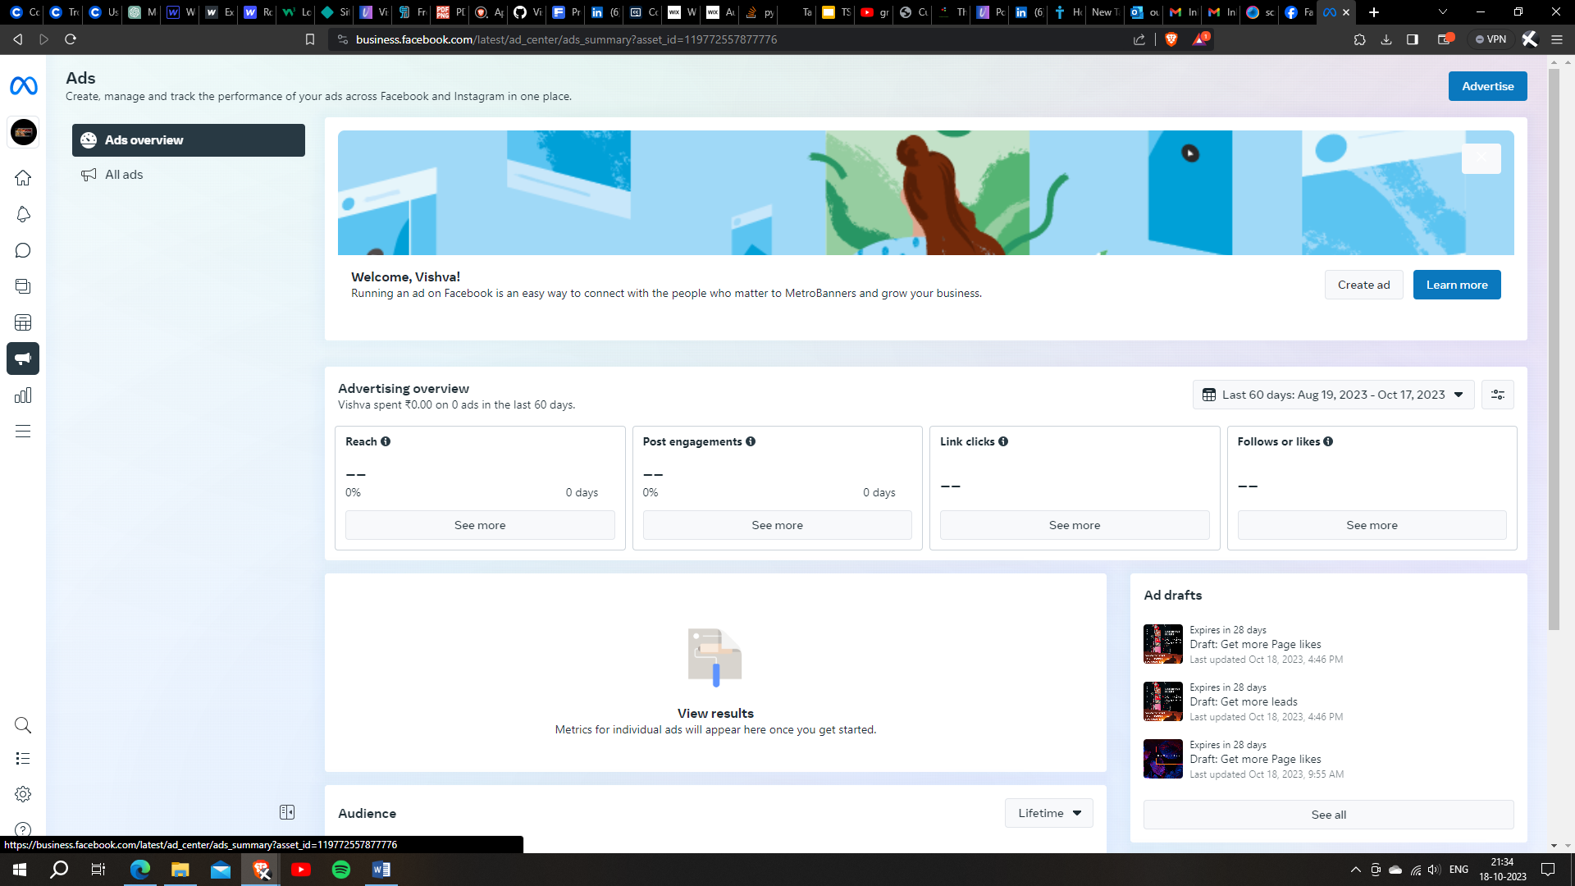

**Step:3**

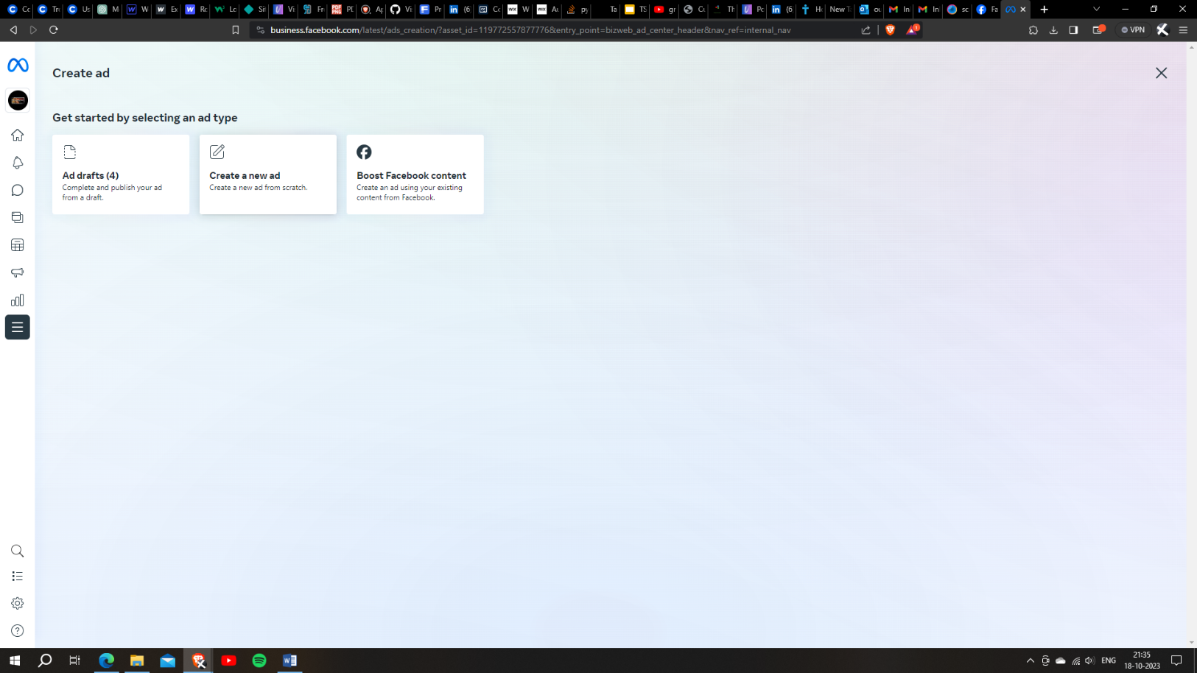

**Step: 4**

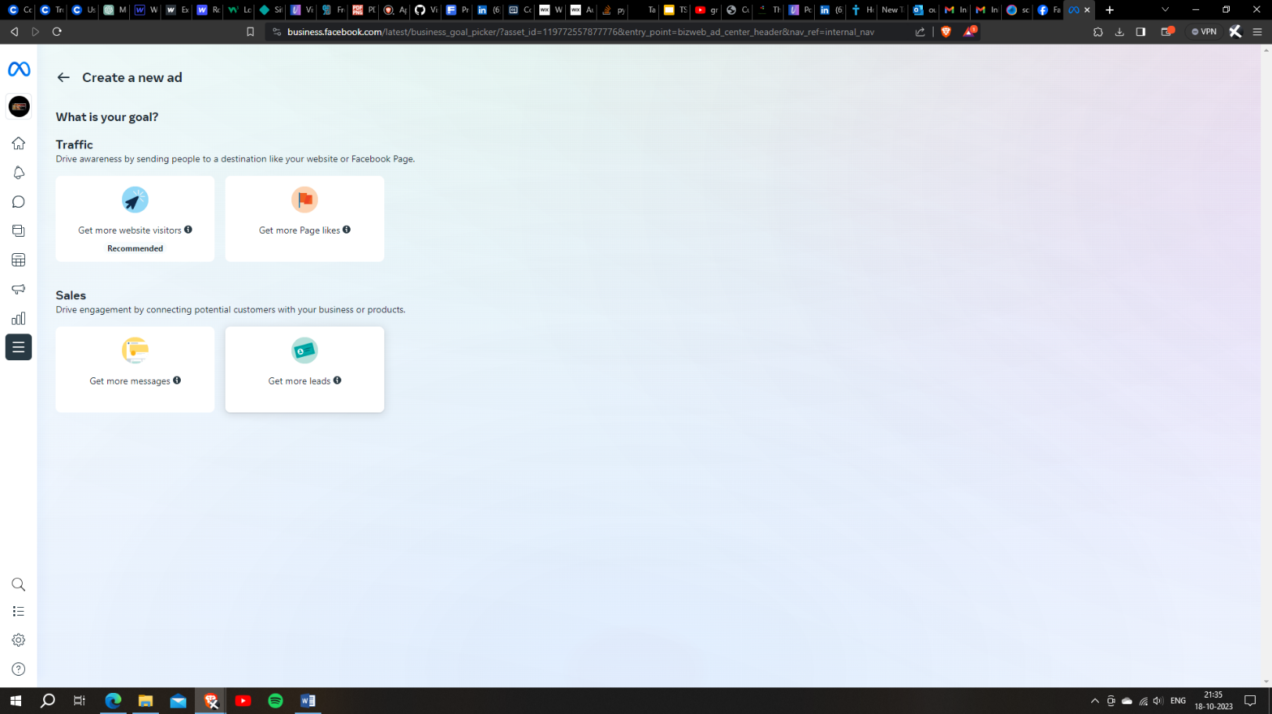

Step: 5

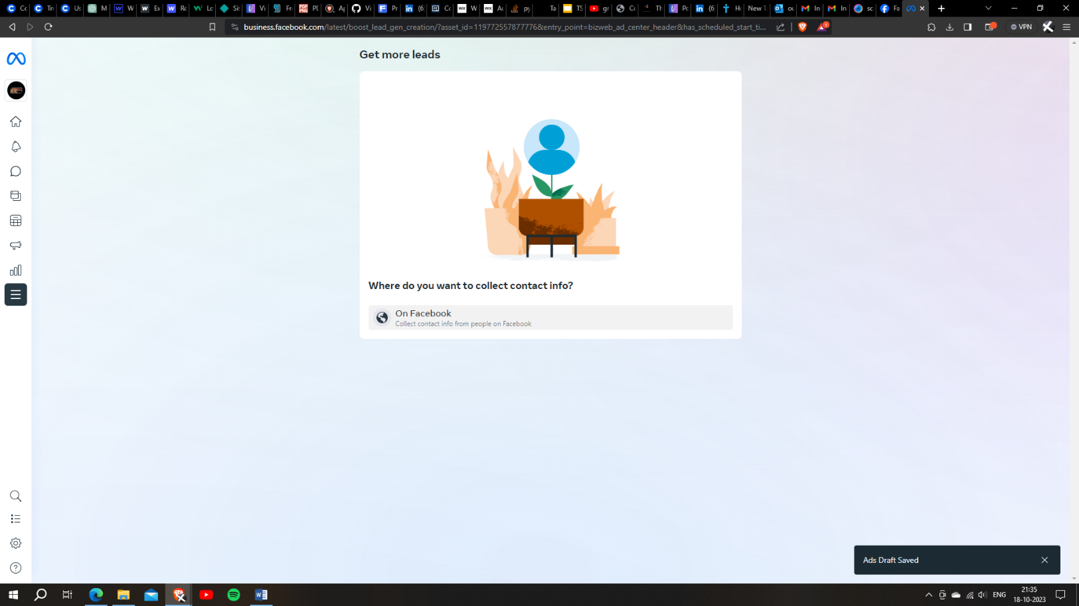

Step: 6

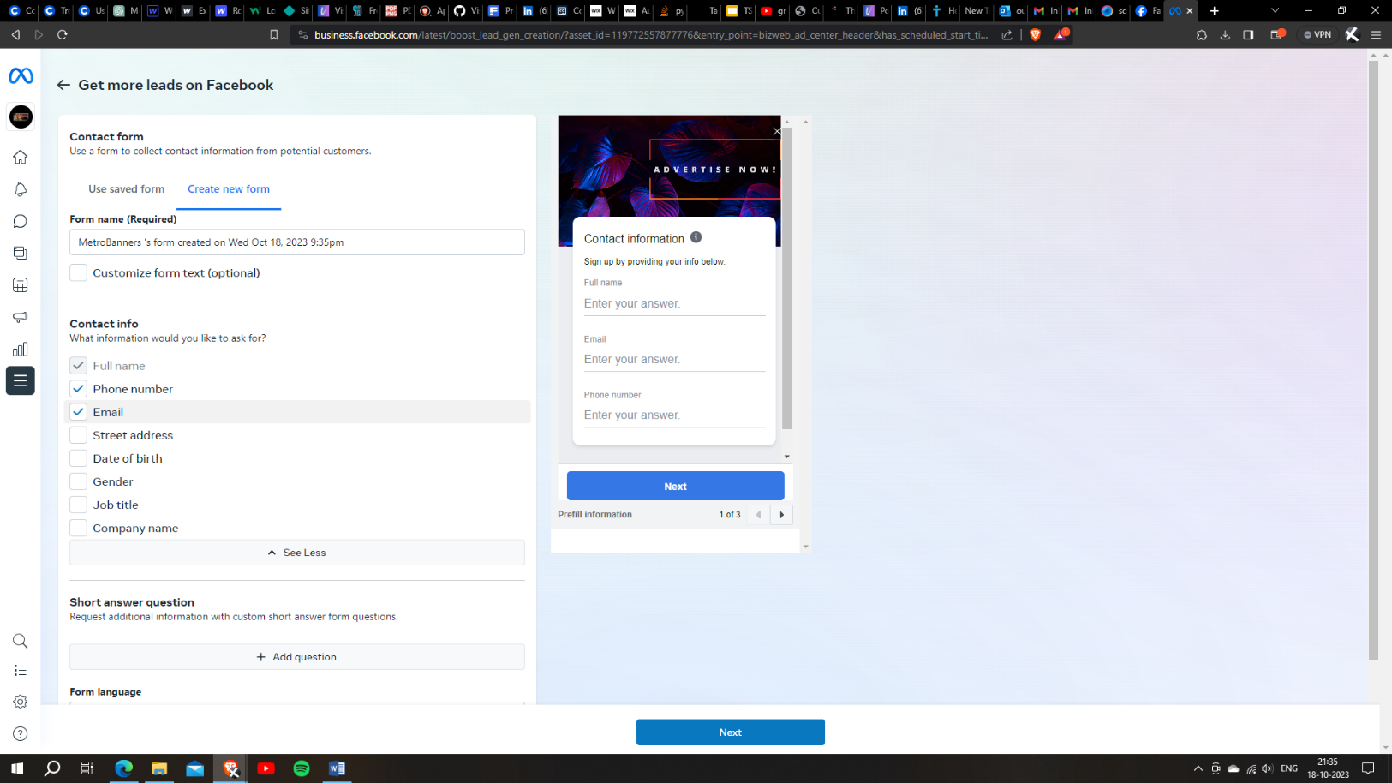

# Step: 7

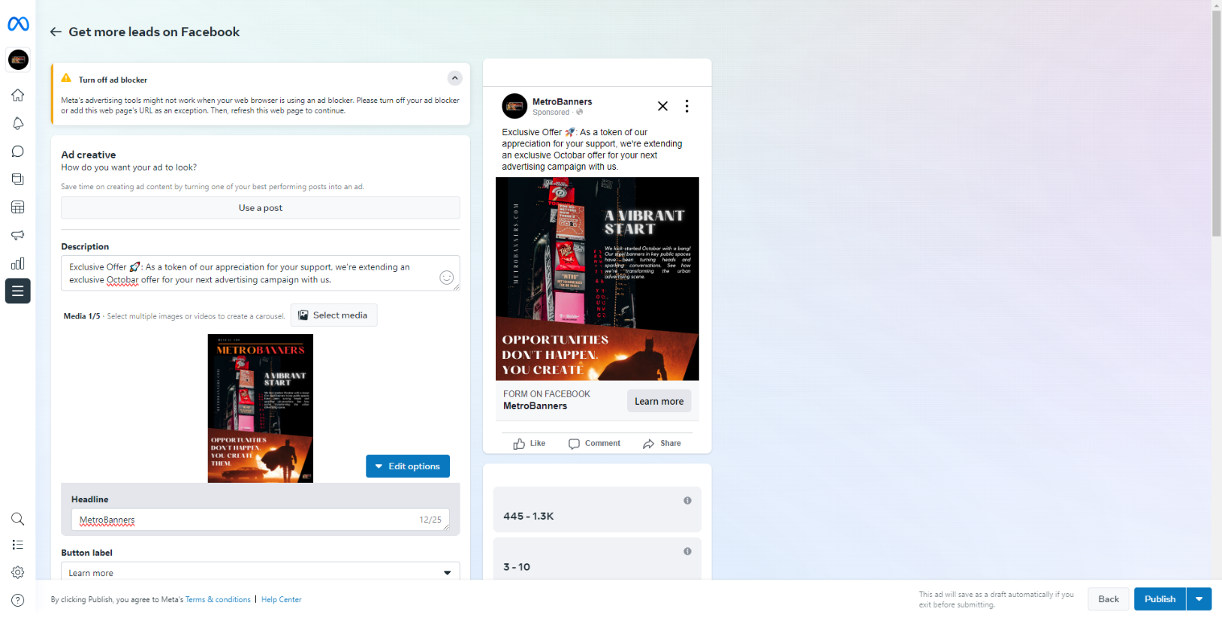

Step: 8

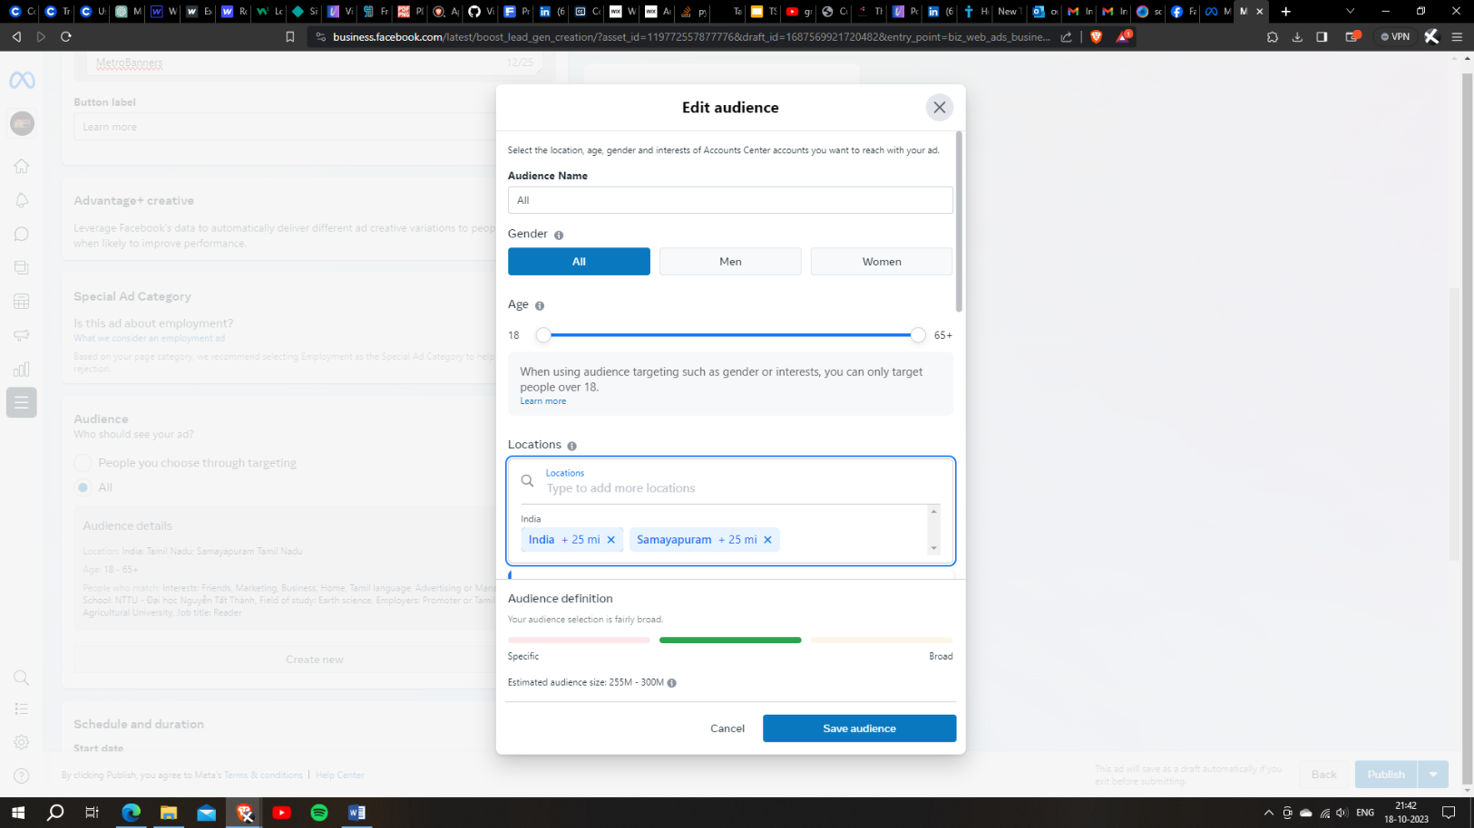

Step: 9

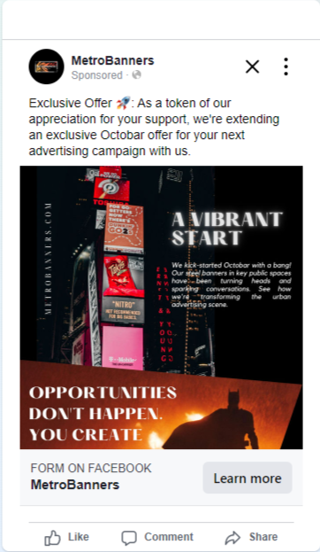

Personal Assignment

**Brand Name: A²S CABS**

**Tag Line:** A²S CABS

**Category:** Taxi Service

**Linked In:** <https://www.linkedin.com/in/aravindsurya>

**Facebook:** <https://www.facebook.com/AASCabs/>

**Blog:** <https://a2scabs13.blogspot.com>

**Brand Intro:** <https://a2scabs13.blogspot.com/2023/08/navigating-cab-offers-guide-to-ensuring.html>

**Email Newsletter:** <https://a2scabs13.blogspot.com/2023/08/email-news-letter-a2s-cab-service.html>

**Infography:** <https://a2scabs13.blogspot.com/2023/08/green-rides-for-sustainable-future-a2s.html>

**Google Analytics Measurement Id:** G-ECFDDKE3QT